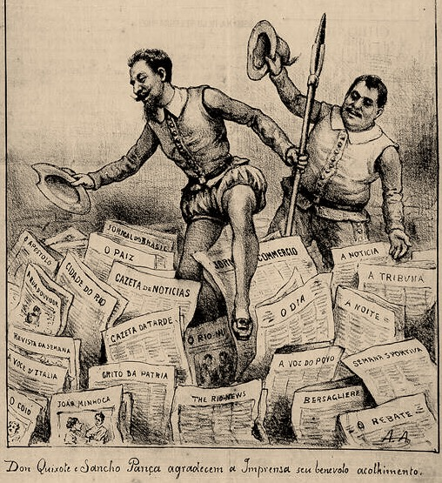
The Transfopress group (CHCSC-UVSQ) was created four years ago to study the periodical press published in foreign languages. Almost always excluded from national historiography, cited episodically or restricted to research on immigration, this press composes a corpus that has drawn attention to the new issues that it raises. Its singular characteristic provokes reflections on the existence of cultural enclaves in environments of apparent national homogeneity. It also raises ideas about transnational exchanges that result from interactions between multiple actors. Brazilian researchers have been dedicated to register, organize and analyze magazines, newspapers, almanacs, and all sorts of journals published in foreign languages in the many projects that compose the set of presentations in this seminar.

  - Fundação Casa de Rui Barbosa
  - Rio de Janeiro- BRAZIL
November 13-14th 2017

CALL FOR PAPERS
30th july 2017

3rd Transfopress Brasil Conference

The foreign language press: between identity and otherness
Program Committee
Isabel Lustosa
Tania Regina de Luca
Valéria Guimarães

Working Committee
Marília Lutfi
Heloísa Campanhã
Luís Felipe Dias

Promotion
FCRB
UNESP

Support
CNPq
FAPESP
The 3rd Transfopress Brazil Conference, to be held at the Casa Rui Barbosa Foundation, Rio de Janeiro, on November 13th and 14th 2017, marks the end of the first phase of this collective effort with the presentation of the research carried out so far, the launch of the book Imprensa em língua estrangeira no Brasil: primeiras incursões and the inclusion new contributions in view of the continuity of the project.
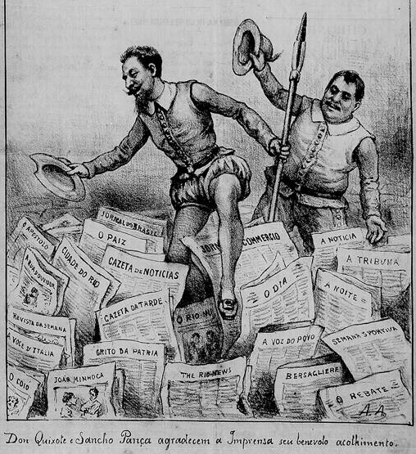

Deadline for abstract submissions: July 30th, 2017.
Format
– Title (specifying geographical and chronological limits);
– Summary: 10 to 30 lines;
– Information: Name, title, institution, e-mail address;
– Minimal title: PhD;
– Proposals must be focused on any foreign language periodical press published in Brazil (Portuguese-speaking press is excluded)
– Language: Portuguese, French or English
Dom Quixote e Sancho Pança agradecem a Imprensa seu benévolo acolhimento.
(Don Quixote and Sancho Panza thanks the press for their benevolent welcome
Detail: Brazilians newspapers such as The Rio News, Il Bersagliere and La Voce d’Italia among others national newspapers)

Magazine Dom Quixote, RJ, 1901

Send to: transfopress@uol.com.br

Listeners
No previous registration required for listeners.

Site: http://transfopressbrasil.franca.unesp.br

